3. Word search
Grouping: 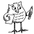

Worksheet 1
Try to find the following words: sjokolade, chocolade, schokolade, chocolate, czekolada, cioccolato, choklad and chocolat

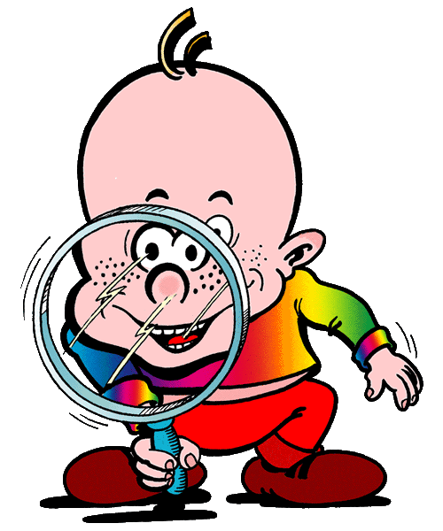
T F N S H W R E O O R E I F
F N E J C W I R M O R G D F
T Z D O Z N Q O I T C F S H
I A E K E N S M D A Q C E S
O I U O K E N R S L H R D D
F T O L O N T A L O C O H C
L F N A L F A A C C D C E C
U R P D A H I O L C O R E S
H M C E D A L O K O H C S A
S I S H A A I N I I C K S S
T E E T D M T J C C I O R I
D A H E S C E N Q A V C H H
T W N A P M S D A L K O H C
P G N N T C D L I R M C B A

